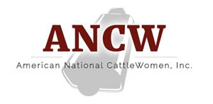
Region IV Agenda

Thursday, May 2nd

Guest arrival
Gathering room at the hotel open at 8 p.m. Light snacks/drinks
Dinner on your own or with a group (cost not covered in your registration)

Friday, May 3rd

8:00 Registration open in Ozark Conference Room
8:30 Welcome
8:45 Speaker – Dr. Janeal Yancey, Meat Scientist and “Mom at the Meat
Counter” blogger
9:30 Break
9:45 Speaker – Scott Meiers, BDS Animal Supply
10:30 Get ready to go to Lavendar farm
11:00 Lavendar Farm/Lunch
1:30 Osage Creek Cultivation
3:30 Back to Hotel
Free time
6:30 Dinner at the McCall’s

Saturday, May 4th

9:00 Ruth Coffey, ANCW President
9:05 ANCW Business meetings
10:00 Break
10:15 CKP Insurance – Suzanne Menges
10:30 ANCW Update – Nikki Weston
12:00 Dismiss with a to-go lunch

